React

Create a react app for Student Management Portal named studentapp

Create a new folder under Src folder with the name “Components”.

Add a new file named “Home.js”

import React from 'react';

function Home() {

  return (

    <div>

      <h1>Welcome to the Home page of Student Management Portal</h1>

    </div>

  );

}

export default Home;

Add a new file named “About.js”

function About() {

  return (

    <div>

      <h1>Welcome to the About page of the Student Management Portal</h1>

    </div>

  );

}

export default About;

Add a new file named “Contact.js”

function Contact() {

  return (

    <div>

      <h1>Welcome to the Contact page of the Student Management Portal</h1>

    </div>

  );

}

export default Contact;

App.js

import './App.css';

import Home from './components/Home';

import About from './components/About';

import Contact from './components/Contact';

function App() {

  return (

    <div className="App">

      <Home />

      <About />

      <Contact />

    </div>

  );

}

export default App;

Run command npm start in command prompt

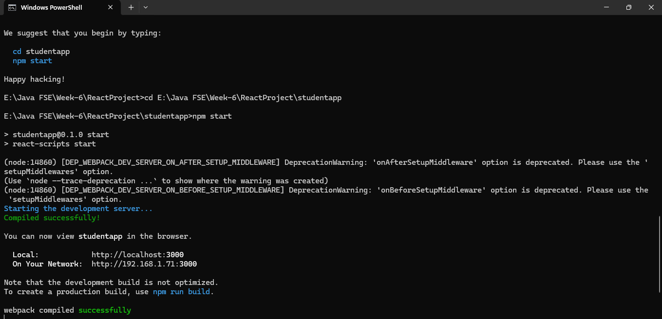

Open browser and type “localhost:3000” in the address bar:

